Wiring diagram

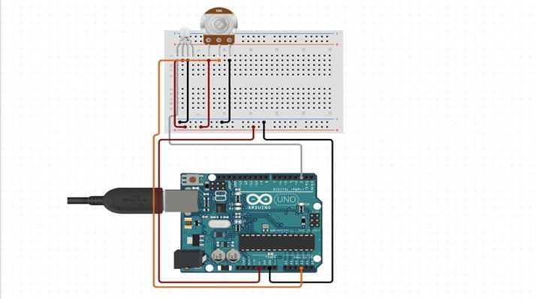

Prototype explanation:

Simply the prototype contains an Arduino uno ,PC, POT, and LED . By using UART interface we were able to connect the pc and Arduino. Also we used ADC protocol to convert the analogue signal read by the Arduino to digital. The POT was used to get readings based on different resistance and the led was used to know if there is a reading or not.

Code Brief:

The code was written by C programming language. UART and ADC protocols was used in this code.

BOM:

I used simple componets which were cost effective such as the POT and LED .

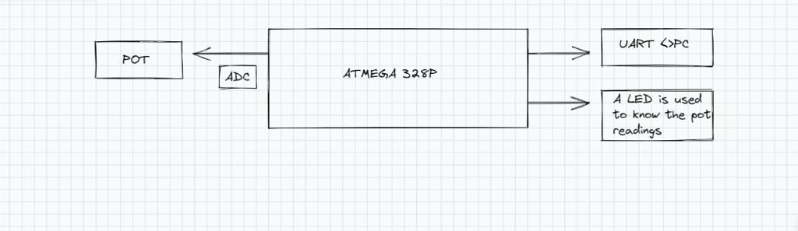

Readings:

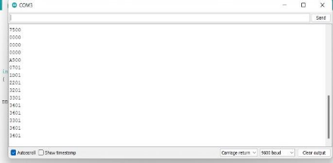

Photo of the prototype:

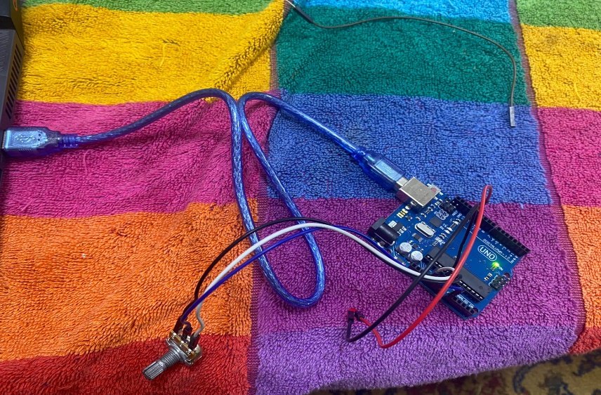

Conclusion:

Finally we were able to develop a UART interface between the ATMEGA328P and the PC. Also we converted the analogue signal to digital by using the ADC protocol and taking readings from POT.